## Q&A Master Doc

**General**

1. **How to derive the weak form if you know the total potential energy?**

Take the directional (variational) derivative of the total potential energy to find the weak form.

1. **How to derive the element stiffness matrix?**

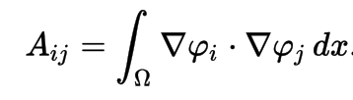

For the case of a triangle with indices (x1,y1), (x2,y2), (x3,y3), we define the following matrix:

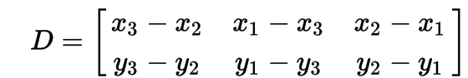

And from there, determine the element stiffness matrix:

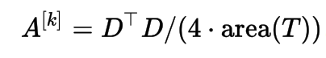

1. **How to calculate the element external force?**

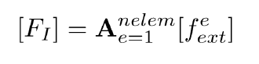

1. **How to assemble global stiffness matrix?**

The global coordinate system is usually the cartesian coordinates. Hence, we need to put the

element stiffness matrix into cartesian coordinates by using sine and cosine functions.

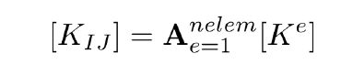

**Project-specific Questions**

1. **What is warping?**

Extensional Deformation in the direction of the axis about which the torque is applied.

1. **How to take variational derivative?**

Take partial derivatives of the total potential energy equation and sum them up. The variables in our equation are theta and psi

For our problem:

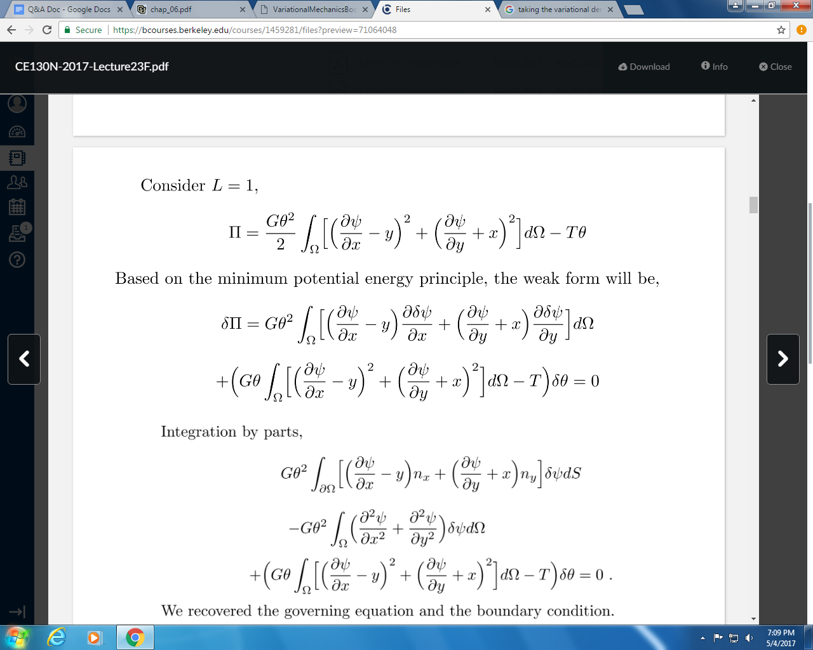

1. **Understand and derive boundary condition for both Saint-Venant torsion and Prandtl stress function problem? WAT**

**-(Andy) I am unsure how to answer this question? Even with the knowledge that we have from the theoretical stuff :/**

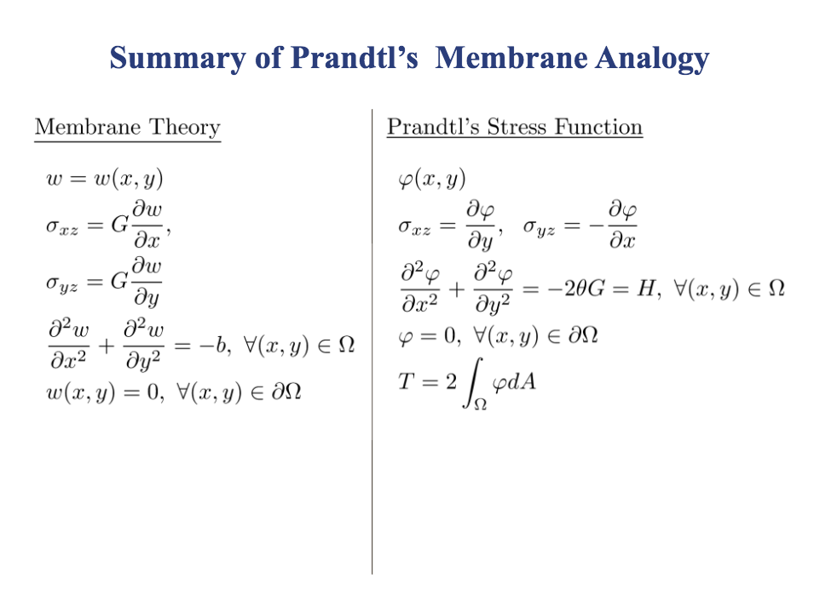

1. **How to construct kinematically admissible trial functions?**

Consider the kinematically admissible displacement *ũ*(*x*)=*u*(*x*)+αδ*u*(*x*) where the variation

from the exact solution *u(x)* is given by the function δ*u*(*x*) times the parameter α. Since *ũ*(*x*)

must satisfy the same kinematical boundary conditions as *u(x)*, it follows that δ*u*(*x* = 0) = 0.

1. **As a special Ritz method, what are special advantages of Finite Element Method?**

The Rayleigh-Ritz setting results in finite element methods having the following desirable

features:

1. General regions and boundary conditions are relatively easy to handle and higher-order

accuracy is relatively easy to achieve

2. The conformity of the finite element spaces is sufficient to guarantee stability and optimal

Accuracy

3. For systems of PDEs, all variables can be approximated using a single type of finite element

space

4. The resulting linear systems are sparse

1. **What is the main difference between the Prandtl stress function method and the Saint-Venant torsion solution?**

**-(Andy)** I would argue the main difference is the approach to problem that we are solving. The Prandtl Stress function uses the boundaries of the cross-sectional area, and helps create a new function. This function can be used to create an analytical solution to the Torque and Shear Stresses. The Prandtl Stress function is often used for non-circular *(or elliptical) cross sections as it can be hard to define the boundaries of other shapes.

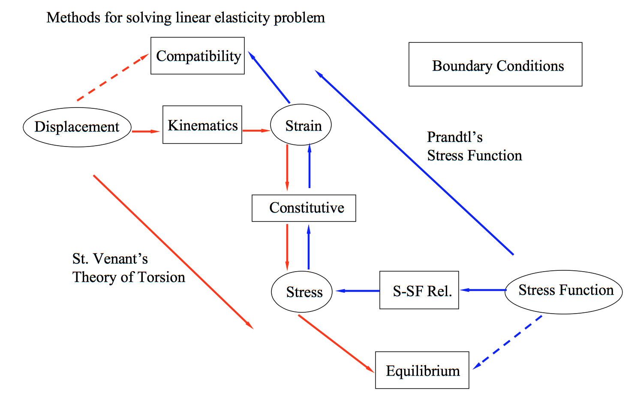

[**http://www.colorado.edu/MCEN/MCEN5023/chap_06.pdf**](http://www.colorado.edu/MCEN/MCEN5023/chap_06.pdf)

The main difference is that in St. Venant’s Theory of Torsion, displacement is used for

calculation purposes while in Prandtl’s stress function, stress is used to solve the given

problem. For this project specifically, the Prandtl stress function is developed to simplify the

boundary conditions of the problem and provide a cleaner representation of the stress fields as

compared to the warping function used in St. Venant’s Torsion method.

1. **What are the main differences between method of conservation energy and minimum potential energy principle?**

The concept of conservation of energy only provides a single scalar equation and thus it only allows for the determination of a single quantity of interest. If a problem of interest involves more than a single scalar unknown the method does not furnish a sufficient number of equations to allow one to solve for a system’s response. It is also noted that the method is not particularly convenient when dealing with non-linear conservative systems. The minimum potential energy principle is a statement of equilibrium and avoids the limitations associated with the concept of conservation of energy. One very important advantage is that it also permits one to devise approximate solution methods in situations where exact solutions are not possible or not needed.

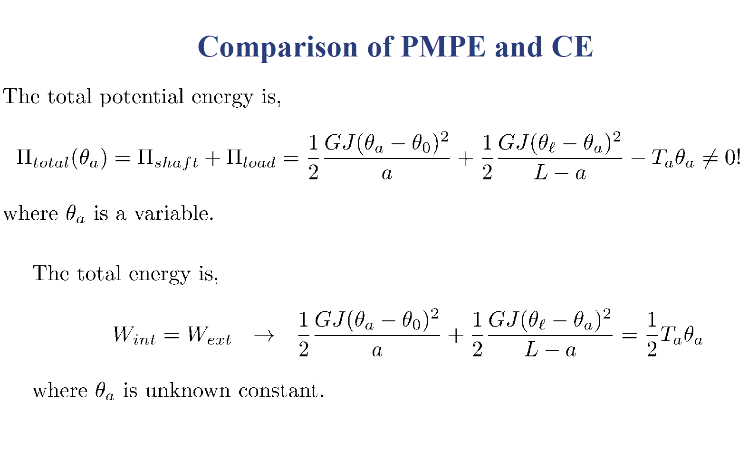

1. **What is the conservative force?**

Force (or force systems) where the work done by the force is path independent. Can be tested

by taking the partial derivatives of a force field and seeing if they are equal.

1. **Given a weak formulation of the assigned project, can you derive the strong form and the natural BC?**

**-(Andy)** The strong form can be re-derived as in the slides using the chain rule. It should be included in the slides and it would be great to put it here for answering the question.

1. **Given a weak formulation of the assigned project, can you derive the FEM discrete algebraic equations?**

**-(Andy)** The FEM formulation is partially code and partially us. The shape function matrix making, that is, where we found all the c constants is the first part of it. I’m sort of unclear on how it gets put into the big matrix though